**Project Understanding**

**What is GCR Shopping about?**

* GCR Shopping is an Ecommerce web-based Application, which helps to deliver the product to end user quickly from any remote location
* This platform is benefitted to the owner by selling products and benefitted to **users** by purchasing the required product.

**GCR from Technical View**

* Site has 2 views Frontend and Backend

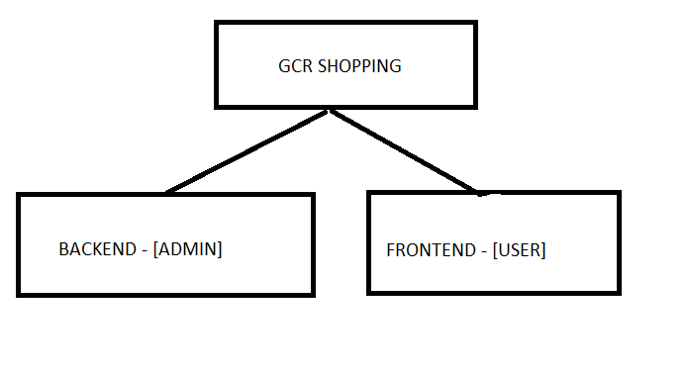

* **Frontend** helps users to search for products, view products, and buy products with an ease of access.
* **Backend** helps admin to manage products and track user details, Admin is the only authorized user to access admin dashboard.

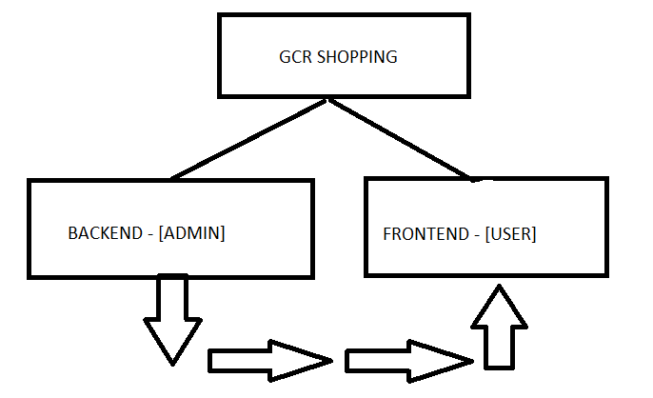

* Products / User’s Details that are Added, Updated, Deleted from Backend [i.e, by admin] will reflect on frontend.
* **Important Features in Frontend**

1. **Categories:**

* Categories is one of the filter methods that will help users to find the required item with an ease of access.
* Categories will be visible on frontend only when it is added from backend.
* Categories can have subcategories.

1. **Search Filter**:

* Search Filter is another method that will help users to find the required items with an ease of access.

1. **User Login**:

* User Login will be applicable to the end user.
* It will help to ensure that only authorized users get access to service.
* User Login will be only done by user registration.

1. **User Registration:**

* User Registration will be applicable to the end user.
* It will help to main user details.
* Users have to register first before login.

1. **Product List:**

* Product List is a list of product items that will be available to users.
* Products into the list are added by the admin from the backend.

1. **Product Detail:**

* Product Detail is a view of a specific product.
* It will display detailed information about the product.

1. **Add to Cart:**

* Add to cart is a service which helps to select user favorite items and maintain the list of selected items.

1. **Write An Review:**

* Write a review is a feature that helps users to add his review in terms of product.
* Users can add multiple reviews.
* User review will be monitored by the admin from the backend.
* Admin can Accept/Reject review.
* Users cannot edit or delete reviews.
* Only Admin can View/Edit/Delete review from the backend.

1. **View Cart Items:**

* Will maintain the list of user selected items.

1. **Remove Cart Items:**

- It will remove the items from the cart list.

1. **Checkout:**

* Users have to pay to buy the selected items from the site, which can be done through checkout.
* Checkout also saves a user delivery address to deliver an item.

1. **Filter Dropdown based on Manufacturers:**

* Filter mechanism which will help users to reach out to his required product.
* **Important Features in Backend**

**A**. **Catalog**

1. Add, Edit, Delete Categories
2. Add, Edit, Delete Products
3. Add, Edit, Delete Manufacturer
4. Approve, Reject, Edit, Delete Review

**B. Customers**

1. Edit, Delete Customers

**C. Localization**

1. Add, Edit, Delete Currencies

2. Order Status

**D. Reports**

1. Customer Orders Total

2. Product Purchased

3. Product Viewed

**A. [Catalog]**

1. Categories:

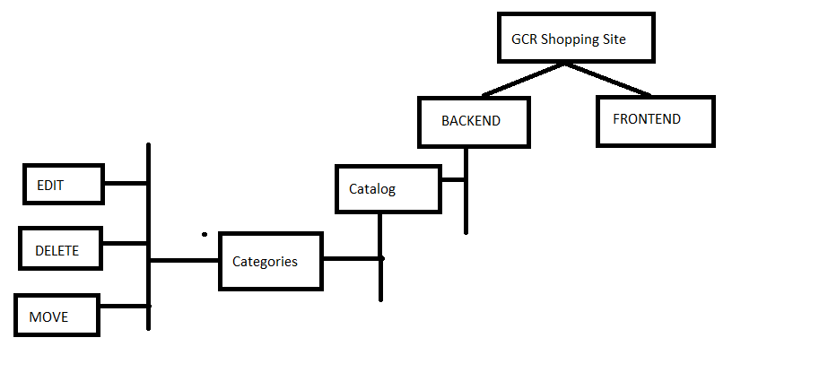

Products will be available to customers on frontend under **categories.**

So, categories can be created into backend with category name, category image,move.

After adding a new category that category will be rendered on frontend, Other than adding, we can manage categories by editing and deleting and setting order.

**Note**: Once a category is edited/deleted it will be reflected on the frontend.

2. Products:

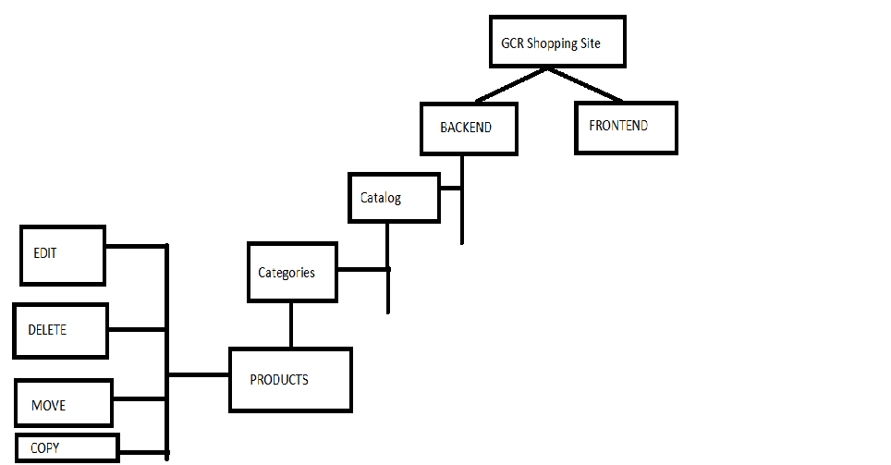

Now only category is not enough or no use until **products** has been added under it,

We can add a new product, here product can be added in two ways: either you can add product directly inside category or you can add product into Top-list and then move product under required category. Other than adding new products, we can manage products by editing and deleting.

**Note:** Once product created / edited / deleted directly under category / created and moved under category same is reflected on frontend.

3. Manufacturer:

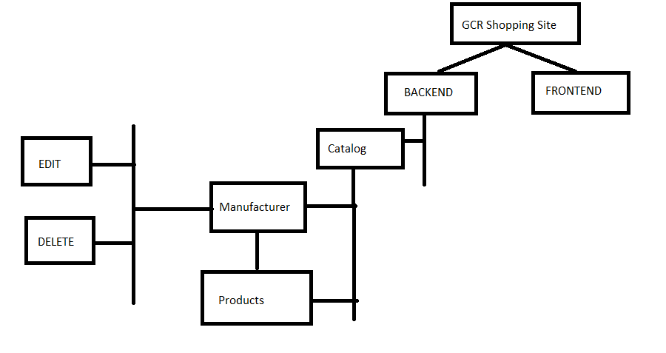

While adding Product there will be one field to select existing **manufacturer** of product from drop down, in order to make manufacturer option available into list we have to create new Manufacturer, other than adding new manufacturer we can manage existing manufacturer from top-list by editing, deleting, While deleting existing manufacturer from list it will ask admin if he wants to delete manufacturer record with only image and other if he wants to delete manufacturer record with all dependent products from product item, this two will be available to admin inform of check so admin is independent to select any option/both option.

**Note**: Once the Manufacturer created / edited / deleted will be reflected on the frontend.

4. Review:

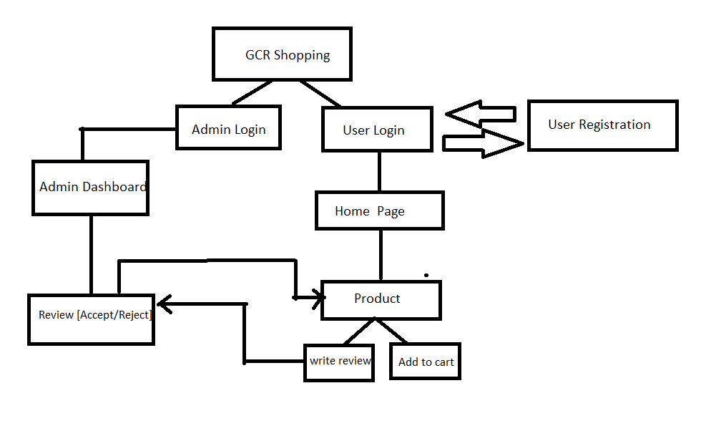

For each products there is review section available on frontend, so that user can add their review regarding the product, after user submit his review, the review is not directly added under product, first it will go for admin to review the user added review, then after when admin approves the review it will be rendered on frontend also admin has option to reject the review which won’t be visible for product.

Admin has the option to manage reviews such as to edit and delete reviews.

**Note:** Edit / Delete of review done by admin will be reflected on frontend.

**B. [Customers]:**

1. Customer:

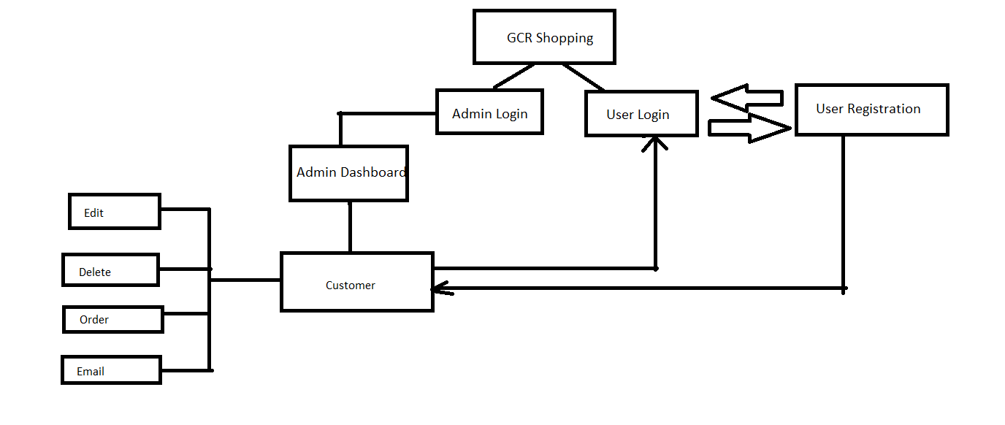

Customer are the main role to play, when customer will register for first time, their details will be stored in Admin Dashboard -> Customer [ password will not be stored]

Other than storing details, Admin can Edit / Delete the user details that will be reflected to the user while login, also the Order and Email feature is available.

**C. [Localization]:**

Currencies use to add the currency which will be reflected into the frontend

order Status.

**D. [Reports]:**

Reports is used to keep track of user activity

1. Customer total order:

* User after completing checkout [i.e, ordering product] his details will be stored into customer total order
* Only signed-in user can order product
* With user order detail further we can print invoice, edit order, delete order, print packing slip etc

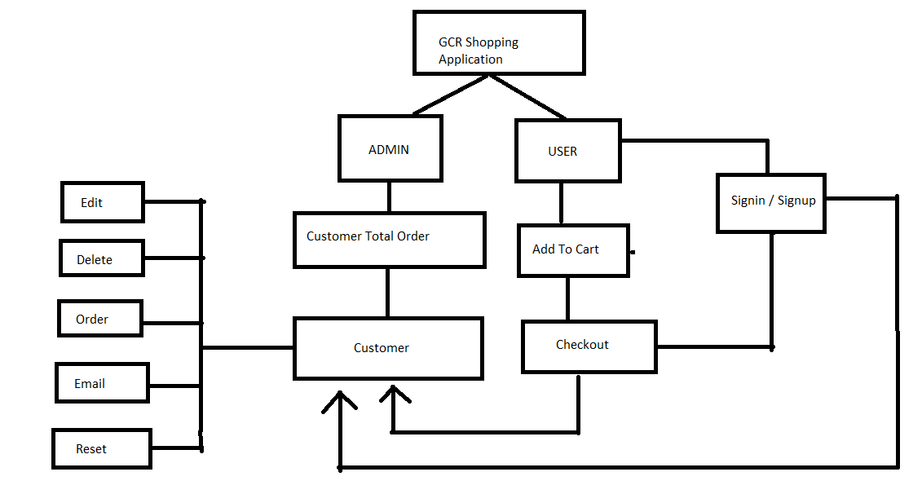

1. Product purchased:

* It will display the list of purchased product list along with its count
* Only authorized user can purchase product

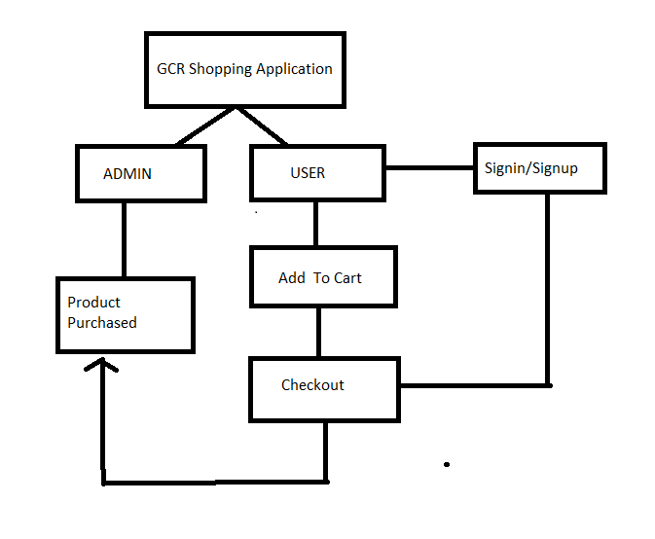

1. Product viewed:

* It will display the list of products that are viewed by customer

